**Business Event Management System**

**Project Report**

**Version 1.0**

Mini Project (Oracle) (BCA551)

Degree

**BACHELOR OF COMPUTER APPLICATION**

July, 2019



**COLLEGE OF COMPUTING SCIENCES AND INFORMATION TECHNOLOGY**

**TEERTHANKER MAHAVEER UNIVERSITY, MORADABAD**

**DECLARATION**

We hereby declare that this Project Report titled Business Event Management System submitted by us and approved by our project guide, to the College of Computing Sciences and Information Technology (CCSIT), Teerthanker Mahaveer University, Moradabad, is a Bonafede work undertaken by us and it is not submitted to any other University or Institution for the award of any degree diploma / certificate or published any time before.

|  |  |  |  |
| --- | --- | --- | --- |
|  |  | |  |
|  |  | |  |
|  | |

Table of Contents

1. Project Title: 4

2. Problem Statement: 4

3. Project Description: 4

3.1. Scope of the Work: 4

3.2. Project Modules: 5

3.3. Context Diagram (High Level): 5

4. Implementation Methodology: 6

5. Technologies to be used: 9

5.1. Software Platform: 9

5.2. Hardware Platform: 9

5.3. Tools: 9

6. Advantages of this Project: 9

7. Future Scope and further enhancement of the Project: 10

8. Definitions, Acronyms, and Abbreviations: 10

9. Conclusion: 11

# Project Title:

Business Event Management System is the title of this project.

# Problem Statement:

Basically, most of the business owners have problem related to their prospects/ customers or related to their sales team because a business runs because of balance sheet,not for balance sheet, for a businessman all the other things are liabilities.

These problems are under define:

* It is very difficult to handle thousands of Prospects / customer related records on paper.
* Due to a lot of thing going on at the same time it is hard to remember all of it prospects name in a specific location.
* If a businessman is going for a meeting to a location then it is very typical to find the name of all those prospects who belongs to that particular location.
* It’shard to remember the names of the active business partners in the business from a specific name if we are organizing Board meetings.
* If a businessman is going to a city for a very short time and he only wants to meet a particular personality type of person then again it is a very typical process to sort out the personality types.

# Project Description:

This project stores the information and data into a data base. And this Business Event Management System focus on the improvement of an information system that will store all information related to prospects and business partners. This project will help the user in easy sorting of data according to any requirement of the user.

## Scope of the Work:

This Business Event management system focus on the improvement of an information system that will store all information related to the eventsthat basically happen in every business: -

* The objectives of this system are to store and sort all the data according to user requirements.
* In this software you can timely update the entries easily.
* This software can give a printout of whatever is on the output screen.
* The User interface of this software is very simple and detailed.
* This software can reduce your efforts up to a great extent.

These points are showing the scope of this Business Event management system.

## Project Modules:

**New Entry:**

In this module user can do a new /fresh entry in any of two categories i.e. prospect or team.

**View/ update:**

This module allows the user to see the full list, to do a quick search among the list according to name, and can delete and update the records of any category.

**Sort/ view:**

This module allows the user to sort / view the data according to its specific requirements so for that we make this particular window customizable and user can also print a copy of the output window.

## Context Diagram (High Level):

USER

Get reports

**DFD 0-Level diagram of Business Event Management System**

This DFD shows the context diagram of Business Event Management System. In this project users give input data and get the output (Systematic reports) after the process of BEMS.

# Implementation Methodology:

System implementation generally benefits from high levels of user involvement and management support. User participates in the design and operation of information systems has several positive data.

First, if user is heavily involved in this systems design, they move opportunities to the system according to their priority and business needs, and more opportunities to control the result.

Second, they are more likely to react positively to the change of the process. In this portal weuse some vb.net and database rules. Incorporating user’s knowledge and expertise leads to a better result.

**Flow Chart**

**MENU OPTIONS**

**New Entry**

**File**

View Reports

**View /update**

**Perform operations**

**Perform operations**

Reports Generated

# Technologies to be used:

## Software Platform:

1. **Front-end:**

In front-end we use Visual Studio 2012.

OS - Windows.

1. **Back-end:**

Microsoft office access database(2007).

## Hardware Platform:

RAM - 4GB

Hard Disk- 40GB

OS- Windows 7/8/10

Editor- Visual Studio 2010/2012

## Tools:

Visual Studio 2010/2012

Database (Microsoft office access 2007)

# Advantages of this Project:

Advantages of this project is under define

* This project is user friendly.
* It is easy to use.
* User only need to save data once in their life time.
* This system can handle and sort data in fraction of seconds.
* This is a memory efficient software.
* This software saving our trees via reducing a lot of paper work and human effort too.
* With the help of this unique system if user is going to a specific location then on an ease, he/she can be able to retrieve information in whatever bases they needed.
* If needed user can also be able to get a hardcopy of the data displayed.
* Customizable software for reports.
* To store the information of the business partners / team members.
* To store the information of the prospects.

# Future Scope and further enhancement of the Project:

* In future the scope of this project can be very good if we include some other new helpful and interesting and time saving features in it.
* This project may have some of the features as follows: -

Training schedule management system

Personal routing schedular

Meeting schedular

Health monitor

Accountability manager

The future Scope of this project is so wide that I can’t imagine because if this could be possible to implement all of the above features into our project it can be a complete package for a Business man and all the Entrepreneurs because to be successful in a business all the above things a necessary to be implanted and maintain the consistency in them.

In near future it is a possibility that this software will be available for different platforms.

# Definitions, Acronyms, and Abbreviations:

|  |  |
| --- | --- |
| **Abbreviation** | **Description** |
| BEMS | Business Event Management System(Title of this project) |
| AI | Artificial Intelligence |
| RAM | Random Access Memory |
| OS | Operating System |

# Conclusion:

## It has been a great pleasure for me to work on this exciting and challenging project. This project proved good for me as it provided practical knowledge of not only database-based application and some extent Windows Application, but also about all handling procedure related with BUSINESS EVENT MANAGEMENT SYSTEM. It also provides knowledge about the latest technology used in developing new technology that will be great demand in future. This will provide better opportunities and guidance in future in developing projects independently.

An attempt is made in all its earnest towards the successful completion of the project. This system was verified with valid data as well as with incorrect data. This project is user friendly since it has been developed in visual studio 2010 a successful Graphical User interface environment. Since the connection can be extended to any database (access, sql etc.). The control will be more powerful of this project. Connecting it to any type of database extends the development control. Any suggestions of user for future development of the system are welcome...... Upgrading the system if may be able to be done without affecting the proper functioning of system....

* This system is developed for Business mans and Entrepreneurs for managing their work.
* Business Event Management System help is maintaining the records of new / old prospects and all the members of a team and also to make our life easier.

**Screen Shots**

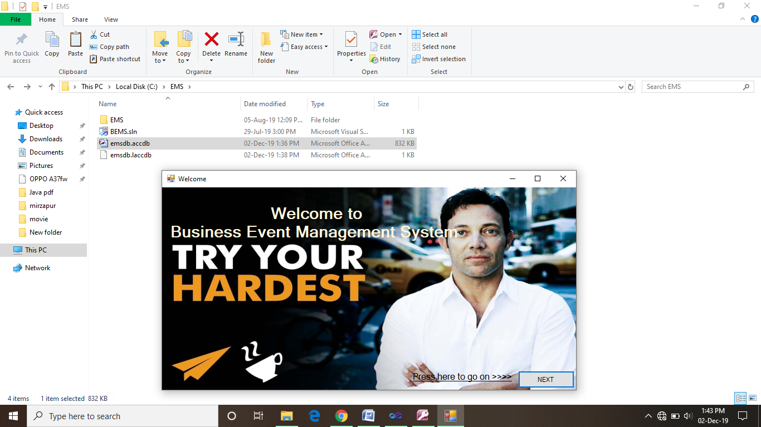

This is the very first Welcome window of the BEMS.

After clicking on the NEXT button we can proceed further and can enjoy the amazing features of the software.

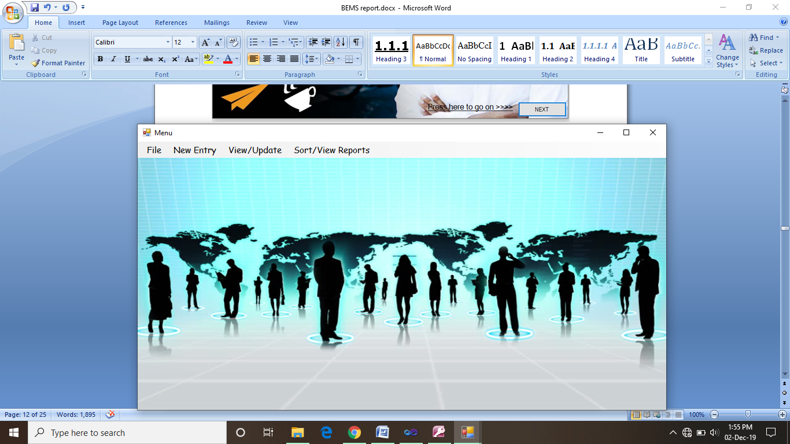

This is the Menu window in which we can perform various kinds of operations related to Managing records of a Business Event/meeting in a useful way.

Business Event Management System data base has only to Tables to manage all the data of any Kind of data i.e. prospect and team.

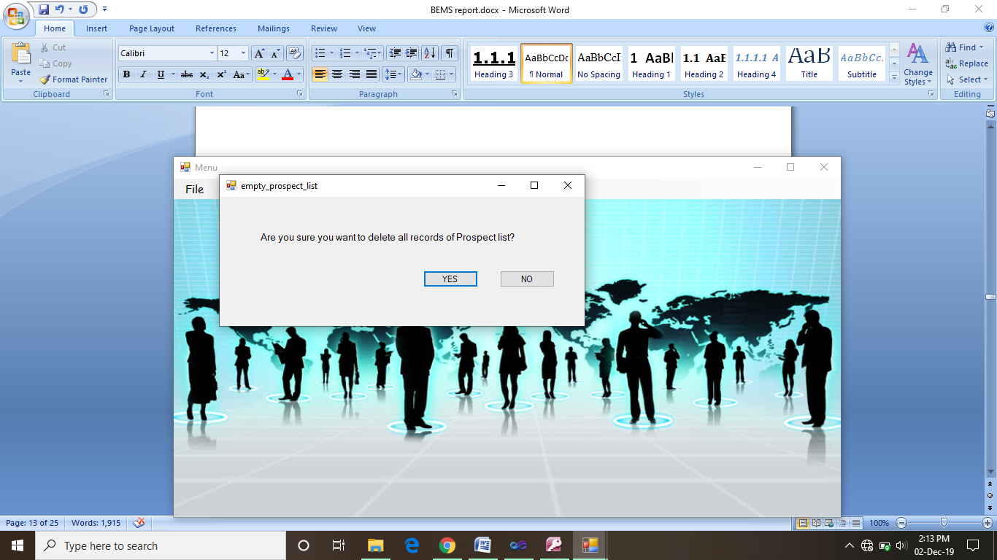

This Empty > prospect list. Option is specially designed to clean up the database prospect table completely at once.

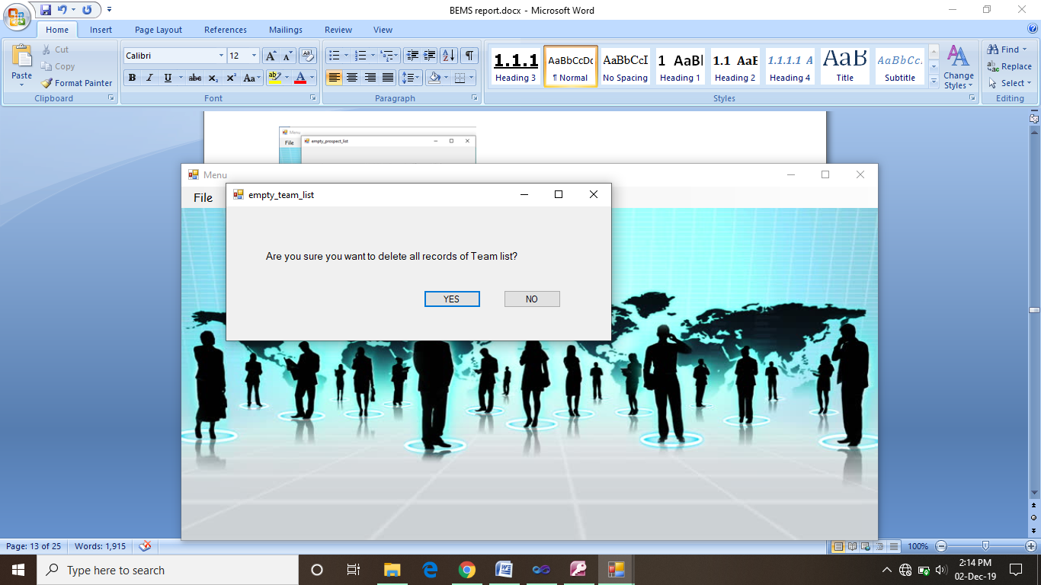

This Empty > team list. Option is specially designed to clean up team table of the BEMS database completely at once.

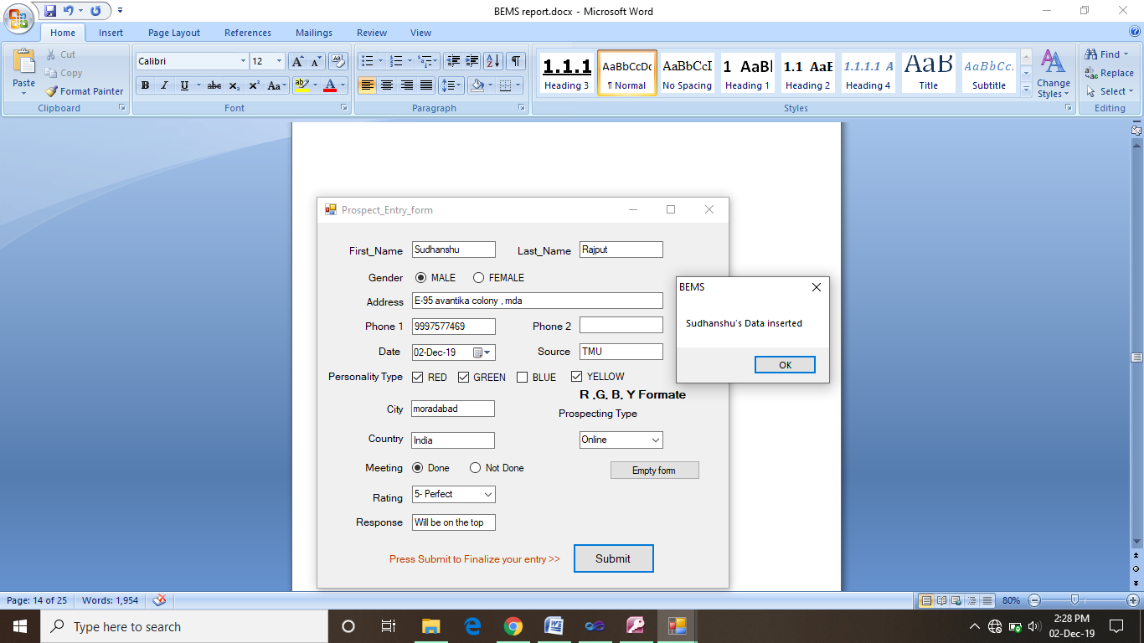

New Entry> prospect opens up this prospect entry form for a completely new entry. From this you can enter the all the information of a new prospect.

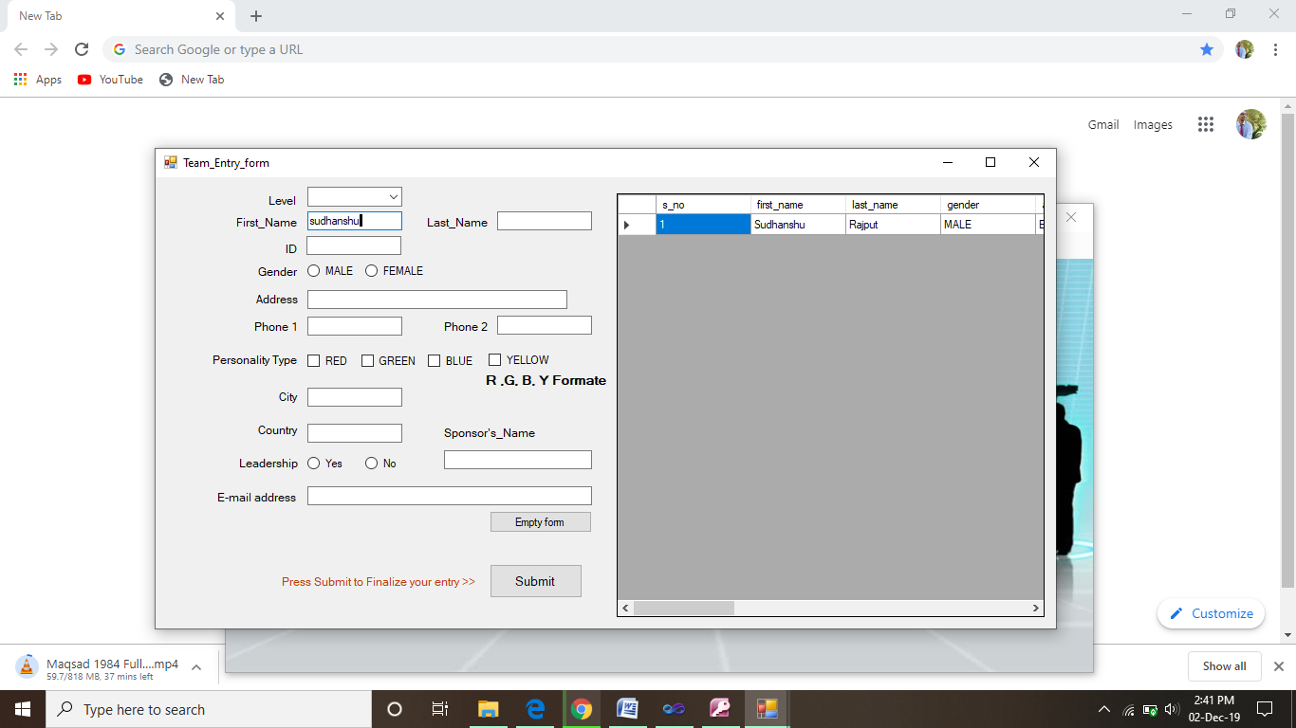

New Entry> team opens up this team entry form for a completely new entry. From this you can enter the all the information of a new prospect.

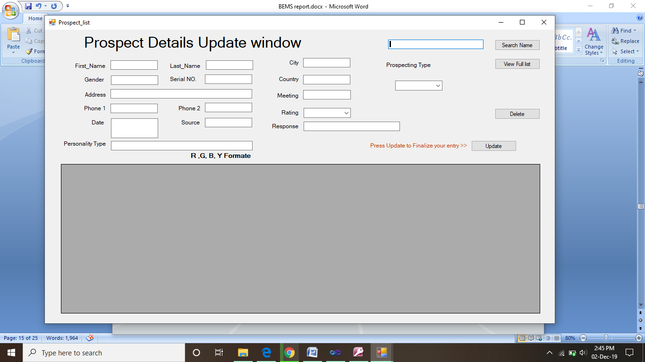

View/Update> prospect list. This feature help the user to view the full list , update , delete and search a particular contact in prospect list.

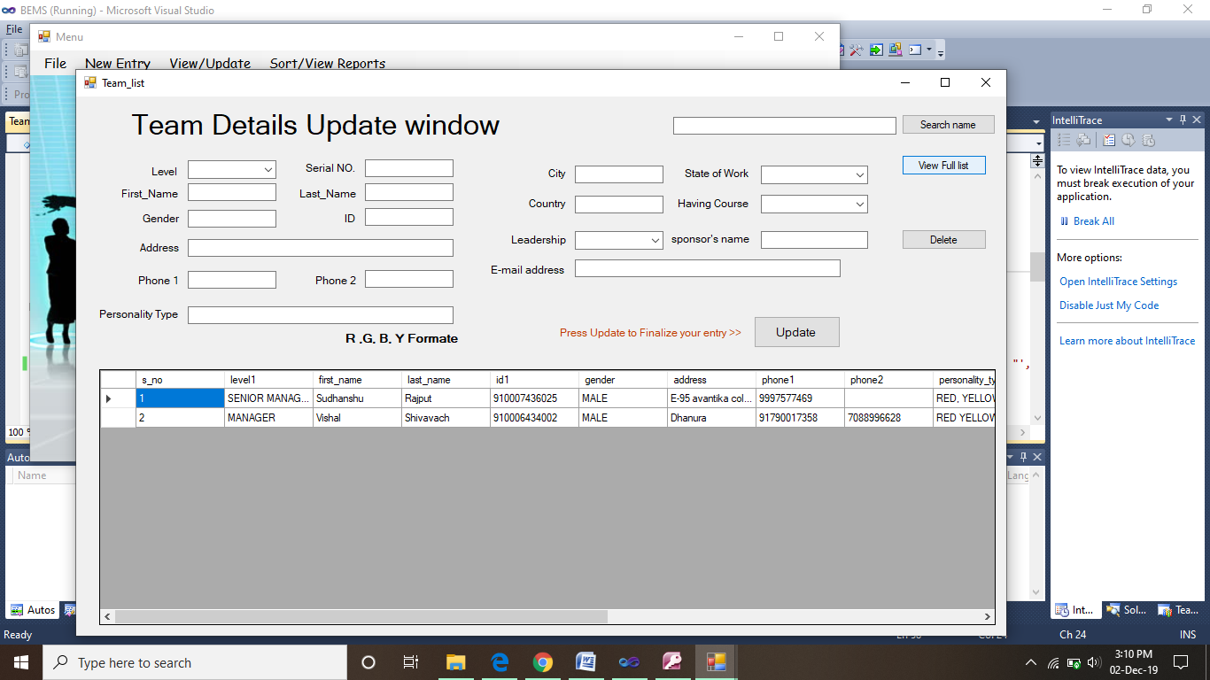

View/Update> team list. This feature help the user to view the full list , update , delete and search a particular contact in team list.

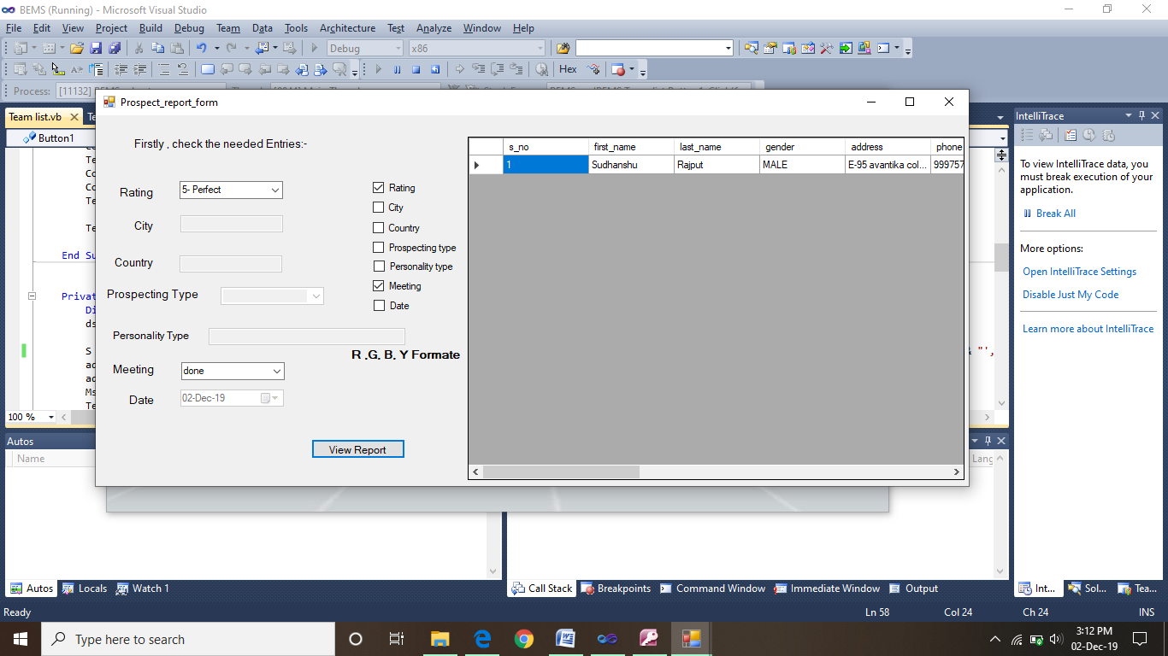

Sort/view reports> prospects> customizable list. This list help to user to get the prospects reports to according to its need at different instances. User can activate the option by checking the check boxes of their respective box to generate the customized reports. As shown in the above screen shot.

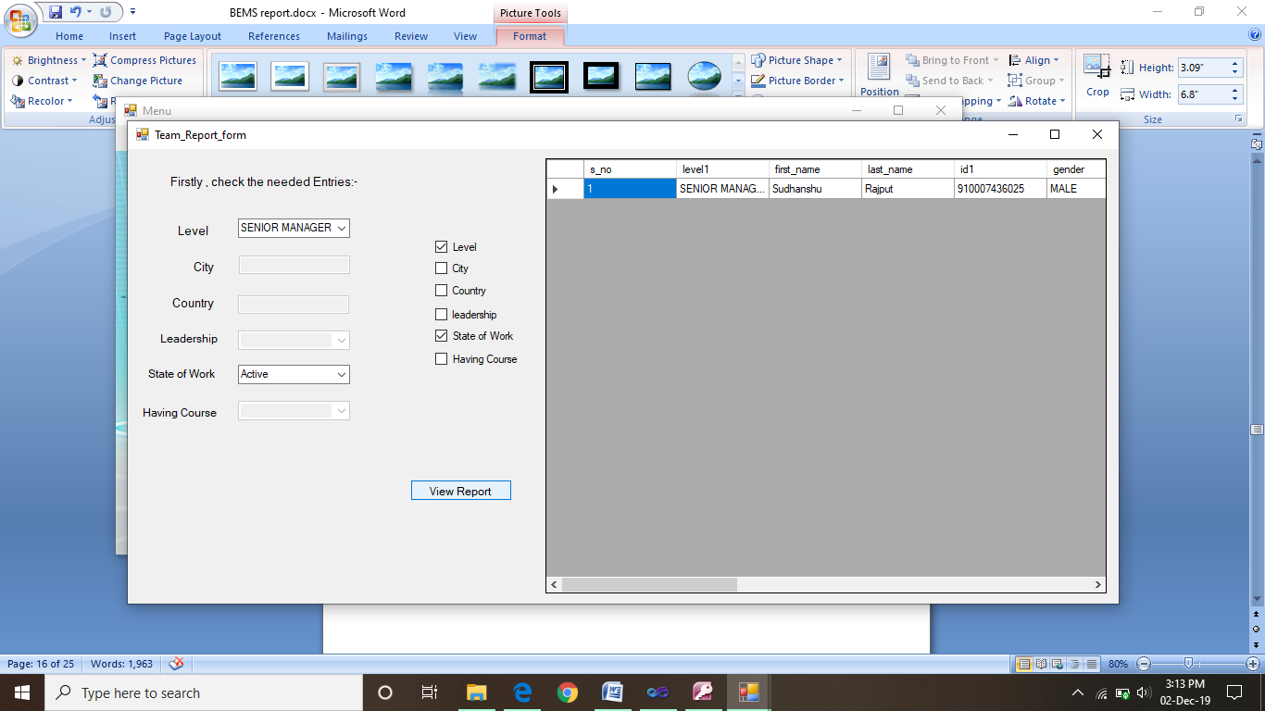

Sort/view reports> team> customizable list. This list help to user to get the team reports to according to its need at different instances. User can activate the option by checking the check boxes of their respective box to generate the customized reports. As shown in the above screen shot.